
AUGUSTA UNIVERSITY

HULL COLLEGE OF BUSINESS

ACCT2101B: Principles of Accounting I

Fall 2026

INSTRUCTOR INFORMATION
Instructor: Sang Hyun (Sam) Park, Ph. D.
Office hours: By appointment (in person or via MS Teams)
Email: sapark@augusta.edu

CLASS HOURS & COURSE MODALITY
Modality: Partially at a Distance — primarily online, with required in-person exams.
Meeting pattern: Tuesday / Thursday Time: 8:30 – 9:45 a.m. Location: Allgood Hall E157
Instruction is delivered primarily online through D2L and MyAccountingLab. You watch the video lectures, complete MyAccountingLab assignments, and take D2L quizzes on your own schedule by the posted deadlines. You are required to attend in person only on the following 5 dates:
- Tuesday, August 18, 2026 — First day of class — orientation
- Tuesday, September 15, 2026 — 1st Exam — Ch 1 & 2
- Thursday, October 8, 2026 — 2nd Exam — Chapters 3 & 4
- Tuesday, November 10, 2026 — 3rd Exam — Chapters 5, 6, 7 & 8
- Tuesday, December 1, 2026 — Comprehensive Final Exam — Ch. 1–9, 11, 12 & 13 (7:30 – 10:00 a.m.)
All four exams must be taken in person in the assigned classroom on the dates above. Please plan your work and travel schedules around these dates now — see the Course Schedule for the full session-by-session plan. The Fall class time is fixed by the Registrar and cannot be changed.

COURSE DESCRIPTION
This is an introductory course in financial accounting. The focus is on accounting as a system for reporting business activity. It includes the study of the accounting cycle, the preparation and interpretation of basic financial statements, and the study of fundamental accounting principles.

COURSE PREREQUISITES
MATH 1101 or MATH 1111 with a grade of C or better

REQUIRED TEXT AND OTHER MATERIALS
- Horngren’s Financial & Managerial Accounting 8th Edition
- MyAccountingLab access is required in order to complete assignments, quizzes, and exams for this course..
- This course uses Augusta University’s Inclusive Access program. If you are enrolled in this course and have not opted out of Inclusive Access, you do not need to purchase a separate MyAccountingLab access code. Your access to the required digital course materials, including MyAccountingLab, should be available through D2L, and the cost will be charged to your student account.
- Please access MyAccountingLab through D2L and follow the registration instructions provided in the “MyAccountingLab_Registration_Handout” on D2L.
- If you choose to opt out of Inclusive Access, you will lose access to the course materials through D2L and will be responsible for obtaining the required MyAccountingLab access on your own. In that case only, you may purchase access directly through Pearson using the link below:
https://www.pearson.com/en-us/subject-catalog/p/horngrens-financial--managerial-accounting/P200000009827/9780137858644
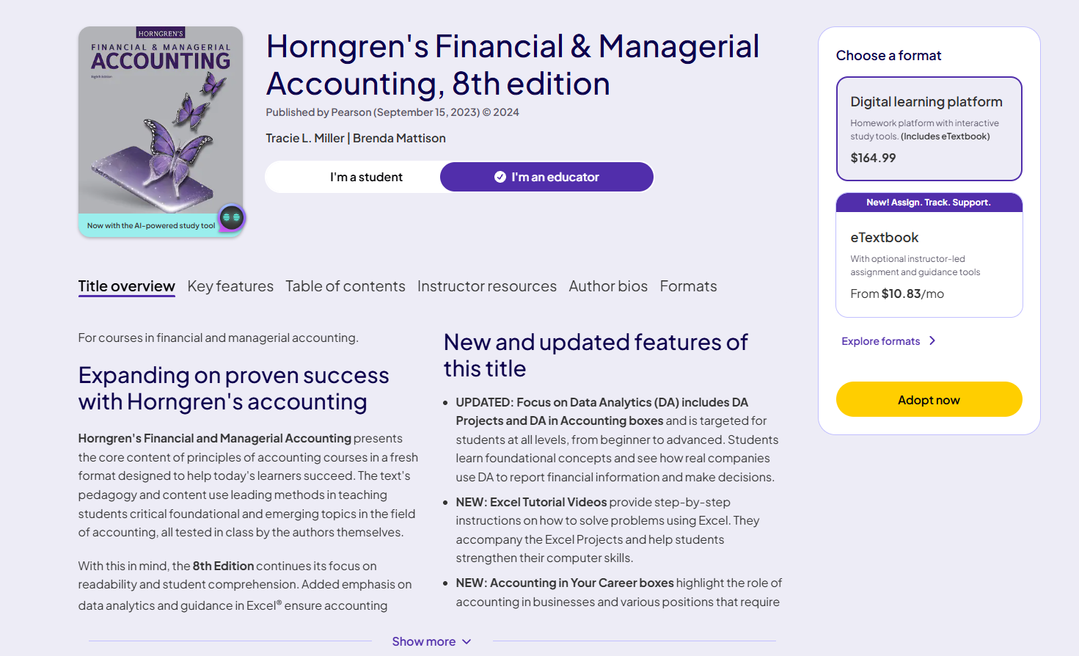
- When purchasing an access code through online store, make sure you select the one of the options in “MyLab” tab above.
- If you already have an access code, you don’t need to purchase it again.
- Make sure that you purchase an access code before your temporary access expires.
- Refer to “MyAccountingLab_Registration_Handout” on D2L to enroll in MyAccountingLab. You must enroll before August 24, 2026.

REQUIRED PERFORMANCE
Accounting majors, accounting minors, and students planning to take other upper level accounting course must earn a grade of “B” or better. Other business majors must make a grade of “C” or better.

STUDENT LEARNING OUTCOMES
Mastery of the material covered in this course is essential for all students, regardless of specialization. The principal learning outcomes of this course are to have each student develop and demonstrate knowledge and basic skills related to:
- Understanding the information system used by accountants, including the process implemented steps in the accounting cycle.
- Identifying the effect of business transactions on the financial statements.
- Understanding the conventions used by accountants to record transactions and the resultant limitations of accounting data in the financial statements based on those conventions.
- Preparing and interpreting basic financial statements.
- Identifying the characteristics of a good accounting system, including appropriate internal controls for a business.
Using the knowledge and skills listed above, students will be able to:
- Construct solutions for problems in business, guided by ethical principles
- Integrate appropriate principles and concepts to inform business decision-making
- Apply appropriate knowledge of technical accounting skills
- Integrate current technologies in summarizing and communicating accounting information

GRADING POLICY

First-Day Class Attendance Bonus Points (Attend on August 18, 2026) | 20 Maximum
Graded Assignments | 200
Quizzes | 200
Ch1-2-practice-test | 100
1st Exam | 100
2nd Exam | 100
3rd Exam | 100
Comprehensive Final Exam | 200
Total | 1000

A | = 900 and above
B | = 800 and above
C | = 700 and above
D | = 600 and above
F | = Less than 600

- Graded Assignments $=\frac{Total Points Earned}{Total Points Assigned}*100$
- Students have the opportunity to earn up to 20 bonus points by attending the required first in-person class meeting on August 18, 2026. Because this course meets in person only five times, that first meeting is where the entire semester is explained — how the online material is organized, how the exams are run, and how to use the study tools. If you genuinely cannot attend, you can still earn the full 20 points by replying to the instructor's welcome email by August 24, 2026. These bonus points will be added to your total score and can help improve your final grade.
Your total score determines your grade. There is no grading on a ‘curve’ and there is no ‘rounding up’ of grades. Accounting majors must earn at least a C in this course. If your major is outside the Hull College of Business, consult your advisor about the minimum grade that you need to achieve.

WITHDRWAL
It is the student’s responsibility to understand when they need to consider withdrawing from a course. October 21, 2026 is the last date that you can withdraw from the course with a “W”. It is your responsibility to formally withdraw from the course by the midterm date to receive a “W”. The only exceptions to this policy are outlined in the AU Withdrawl Policy.

Incomplete
Under emergency/special circumstances, students may petition for an incomplete grade. An incomplete will only be assigned if a student is doing satisfactory work, but for non-academic reasons beyond his/her control is unable to meet the full requirements of the course. A student has one additional semester to complete the required work and to receive a final grade. Any incomplete grade not removed after the next semester will be converted to an “F” grade.

